MY LEARNING ECOLOGY WHILE STUDYING FOR A DEGREE
NAVID TOMLINSON article for Lifewide Magazine

Having just completed a three year archaeology degree at the University of York I am in a good position to look back and try to make sense of my experience using the idea of a learning ecology. For me a learning ecology is defined by the interactions between numerous processes and relationships which are connected for a particular purpose such as are illustrated in Figure 1.

Figure 1 My concept of a learning ecology - a network of processes and relationships linked by a goal or purpose.
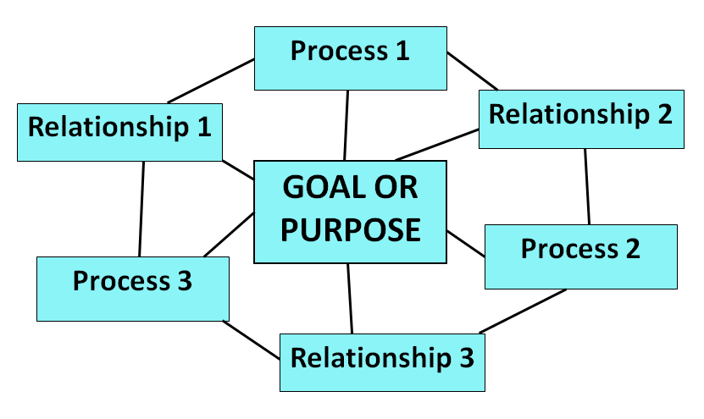

Using this concept of a learning ecology, which focuses on the interaction of my relationships and processes, I can look at the various learning ecologies that I was involved in during the three years I studied for my degree archaeology. The core aim around which my overall learning ecology formed was to develop my understanding of archaeology to the highest possible level I could achieve. I wanted to become a good archaeologist and that ambition caused me to get involved in many things outside my course that I thought would help me become an archaeologist.

The most obvious process and set of relationships I engaged with to learn and understand archaeology was the timetabled and structured university course. This involved the reading of set course material much of it accessed through on-line journals and participation in lectures and seminars in ways that were dictated by the lecturer. This structure that was designed and taught by my teachers allowed me to follow a very clear process of learning, helping me to fully understand what information I had to know within the course. This structured process allowed me to form what I see as the backbone for my learning of archaeology but my personal learning ecology which was much richer than the course itself, was what enabled me to be the sort of archaeologist I wanted to be and become (see figure 2).

The course formed the backbone to my learning about archaeology. It provided me with contacts/relationships with people who were also interested in my subject and enabled me to develop a mind-set that encouraged me to engage with archaeology (both material resources from the course and opportunity and resources outside my course) in ways that are outlined below. My three years of studying, combined with all the other things I did that were related to being an archaeologist formed a significant learning ecology that gradually unfolded over this period of time. I have attempted to represent this ecology in Figure 2.

Figure 2 My learning ecology

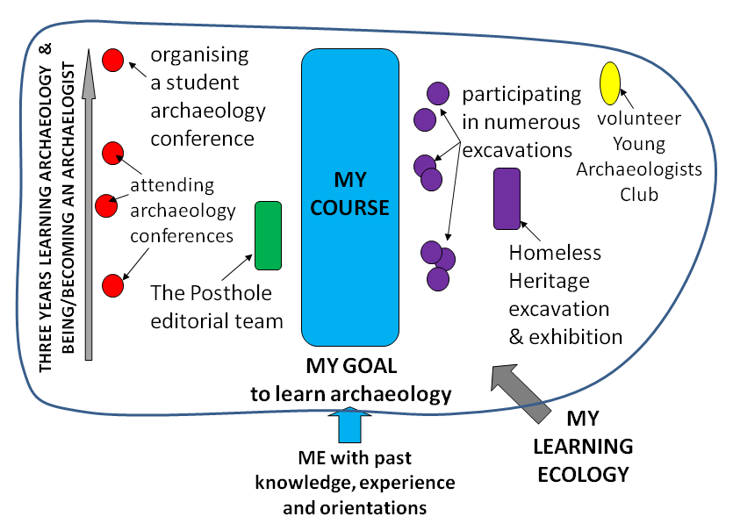

The one experience in my course where I feel I had to create my own learning process was my final year dissertation which required me to create a learning project around something I found interesting and challenging. I had taken a course in my second year which involved a technique called ZooMS for analysing collagen in animal bones to identify animal genus. The academic responsible for developing the technique wanted someone to try the technique on erasure rubbings from bones. I thought this was interesting so I wrote my proposal and created a process that involved me sourcing samples, experimenting using different rubbing and collagen extraction techniques, with the extracted collagen then put through a Mass Spectrometer followed by data processing and writing up the results. Although the process for achieving my goal was not particularly smooth it was one that I had largely created based of my past experiences of academic research gained throughout my three years at University. From an ecological perspective I can see that I involved a lot of different people to help me including my supervisor, laboratory technician, two of my peers who were involved in similar work and as well as sourcing materials from both the local museum and a PhD student within the department. I drew on a range of resources and facilities including collections of ancient animal bones, specialist laboratory, processing software, and articles. The research process was not straightforward and I was forced to modify my process as I realised that certain methods did not give me the results I was hoping for.

But perhaps the best opportunities for me to learn how to be an archaeologist lay outside my course. For example, in my second year I joined a group of students that acted as an editorial team for a monthly archaeology journal called The Posthole, which published articles by archaeology students. I acted as a coordinator and also tried to attract writers. Working within this team was a important learning curve, ensuring that the team operated together smoothly to achieve a goal while bringing together the priorities of different individuals within the team.

Being an archaeologist involves 'digging' to expose artefacts through which we can interpret the past. Unfortunately, my course only provided a four week introductory fieldwork course so I joined a number of 'digs', six in total run by two different PhD students, a member of the academic staff, a commercial company, and an external public organisation. Overall I probably spent over three months on excavations which gave me valuable insights into how to organise and conduct a dig, how to conduct various types of surveys, how to prepare, identify and display artefacts and beyond this how to work as a member of a team. The commercial digs I undertook introduced me to the world of commercial archaeology and the different approaches and mindsets that are used in the commercial world.

One of these projects had a particular significance for me. Homeless Heritage was started in 2009 by a PhD student at the University of Bristol. It is dedicated to working with homeless communities in order to understand and value the spaces used by such communities using archaeological methods. But it is more than archaeologists just applying archaeological techniques to the study of spaces that a particular group of people use: it involves working with homeless people in order to understand the relevance of what is found. In this way I was able to form friendships with people I would never have come into contact with in my student life. I began to appreciate the problems of homeless people and to see the world through their eyes. The experience enabled me to understand the value of contemporary archaeology, but I also began to see a new relevance of what I was doing, through it I became interested in the ways archaeology can be used to engage communities. The excavation was only the first stage of our project, the next stage involved telling people what we had learnt. After carefully cleaning, describing and cataloguing the artefacts we had discovered we organised a week- long exhibition, in which everyone was able to get involved and introduce the project to a wider audience.

There is one more set of experiences that contributed to my overall learning ecology. Throughout the three years of my course I was fortunate enough to attend a number of conferences organised by the theoretical archaeology group. I had to pay for these and they were outside the academic term. I thoroughly enjoyed the experience and it was a great opportunity to be exposed to people working in the field who presented the results of their research. This experience gave me the idea that we could perhaps run a conference for archaeology students nationally . With two other students I spent a significant part of my final year organising and marketing the two day conference which we held in July 2013. It was a great success with over 60 participants. Throughout the months of organising the conference a whole range of problems and issues were raised from working out the live streaming of the conference through to booking rooms and organising payments. Each of these challenges required us as a team to find contacts and resources that would help us to overcome each challenge allowing us to fully develop the conference into the successful project it was.

Through the Homeless Heritage project I developed an interest in the idea of using archaeology as a means of involving people in a community project and I made this the subject of a seminar I had to give at the end of my course. In my final year I began to imagine myself working in the field of 'community archaeology' and I discovered that the Council for British Archaeology (CBA) offered a number of Community Archaeology Training Placements. I decided that I would apply for one of these and to give myself a better chance of securing this position I volunteered to help the local organiser of the Young Archaeologists Club (YAC) and was able to assist her with the running of a number of Saturday trips for school children which I really enjoyed. Unfortunately, because of illness, I was not being able apply for the Community Archaeology Training Placements but the experience provided me with a useful insight into archaeology as a possible career, outside the more traditional roles of archaeologists.

Looking back over my higher education experience I can now see that my course provided me with the basic knowledge I needed but that my attempts to learn archaeology and become an archaeologist involved much more than turning up for lectures and studying the reading list. Many of the experiences through which I learnt and developed myself were part of a bigger self-initiated and to some extent self-created learning ecology. I believe that the choices I made in getting involved in these wider experiences personalised my experience and the learning I gained from it. Most of these experiences were connected not so much to my course but to the bigger context of being amongst, and putting myself amongst, like-minded people interested in archaeology. The relationships I formed with some members of staff and doctoral students in particular opened new opportunities for me and enabled me to find the help I needed when I needed it. Since finishing my course, circumstances have meant that I probably will not pursue archaeology, other than for my own interest, but what I will carry with me is the belief that there are always opportunities to learn and develop if you look for them and if you are willing to get involved.

