Lifewide Education Progress Report January/February 2013
We welcome contributions and news from Lifewide Education Community members.
Team News: We are delighted that Elisabeth Dunne and Ron Barnett joined the Team
Lifewide Magazine 'Becoming the Person we Want to Be'
Jenny finalised and published the Magazine and distributed the notice to networks. Readership stats are impressive. 683 page loads, 578 unique visits 530 of which were first time visitors.
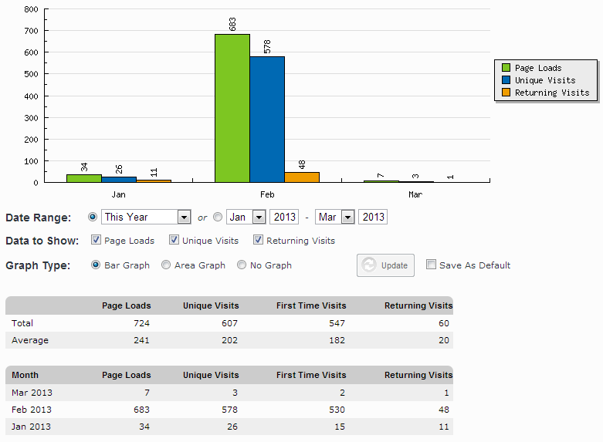

Lifewide E-Book : Edited and published chapters

Brian Cooper completed editing and published two chapters,

D2 Extra-curricular awards : Association of Graduate Careers Advisory Services (AGCAS) perspective David Nelson, Sarah Jeffries and Vicky Mann

D3 Lifewide Development Awards: an emergent phenomenon in UK higher education Charlotte E Betts and Norman J Jackson

John submitted a chapter and it was peer reviewed and revised, and edited by Brian. It will be published in March.

A3 To Each According to Their Needs: thoughts on dealing with emergent learning needs John Cowan
Jenny submitted a chapter C2 Lifewide Learning Survey of Everyday Learning and Development and it was peer reviewed and revised. It will be published in April

Readership stats are beginning to build.

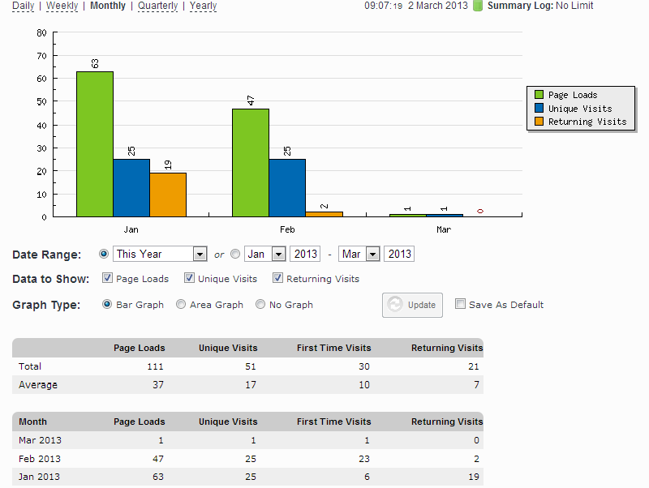

Lifewide Education Collaboration with Southampton Solent University
Norman made two visits and worked with Georgina Andrews (Director of Business School) to put together a proposal for HEA Funding to introduce lifewide education to a range of undergrad and postgrad programmes in two Faculties. DVC signed off the project and has invited Norman for a discussion about lifewide ed.

Lifewide Education Conference
Norman put a proposal together and sought feedback. The proposal was revised around the theme of Learning Lives : Recognising and Valuing Lifewide in Lifelong Learning.

In consultation with Jenny and Russ (both RSA Fellows) a bid for funding (£2000) has been made to RSA Fellowship Fund. The main objective for March is to progress the idea to the point that we can advertise the conference.

Conferences /webinars
Norman participated in an international innovators forum in Riyadh Saudi Arabia making a number of useful contacts.

Jenny participated in the HEAR conference in Leicester and a CRA webinar on Open Badges. Norman is following up Open Badges and there seems to be good potential to link with Lifewide Ed.

Postings made on Lifewide Education

Fifty things to do before you are eleven and three quarters

Tribute to Alice Payne

Care as a core capability

Postings on Linked-in

Little Angels to Little Devils

Care as a core capability
What Makes Us Who We Are?

A Short Story: Kindness

A Short Story : Neurosis

Postings on Facebook

Care as a core capability

Visit to Riyadh

Lifewide Magazine

Lifewide learning entry on Wikipedia

Progress towards work plan objectives

Sustain what we are already doing including: | HAS PROGRESS BEEN MADE?
Production of 4 issues of Lifewide Magazine | yes
Production of at least six chapters of lifewide e book | yes
Maintain the website with regular discussion items | yes
Encourage/facilitate discussion in community forum | no
Maintain LWE presence through social media (Facebook, Linked in, Twitter, RSA Fellowship) | yes
Promote LWE through conferences in the UK and overseas (LWE to participate in at least two international conferences and one UK conference) | yes
Continue with Lifewide Development Award pilot supporting at least 20 participants with an appropriate number of mentors. Identify potential organisational partners. | yes  Bid with Southampton Solent
Plan and organise one or more first face to face events (seminars or conferences) | yes
Engage institutions/organisations/ possibly politicians and their policy advisers | no
Research & Development - to examine the relevance and potential application of LWL/E to  a) identity b) 'wellbeing' and c) 'sustainability' d) frameworks for connecting, integrating and reflecting on co- and extra-curricular experiences and development 16-19. | Yes Lifewide Mag and jj 'Survey of Everyday Learning' chapter

Norman Jackson 02/03/13

